**BLOCK INTERACTIONS**

**ENTER THE GUNGEON**

Our concept is based off the Winshester game in Enter the Gungeon. However, as this is only a minigame, it only features three types of blocks for the player’s projectiles to interact with when hit:

* The blue blocks reflect the projectiles,
* The red blocks destroy the projectiles,
* The green blocks reflect the projectiles and are destroyed immediately afterwards.

Blocks that do not make up part of the walls are either placed stationary, or they move back and forth in a set direction. Sometimes, these are combined into rows of three or a group of four.

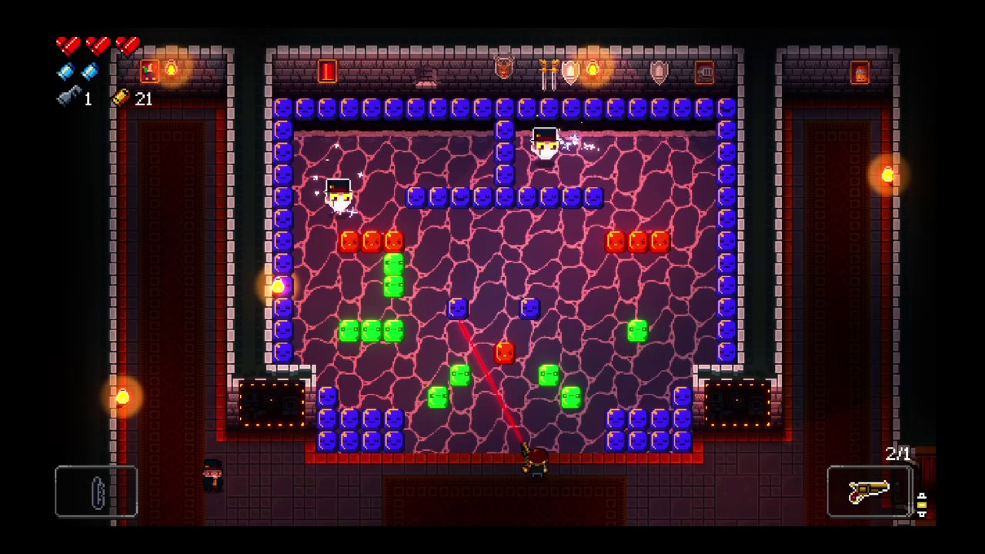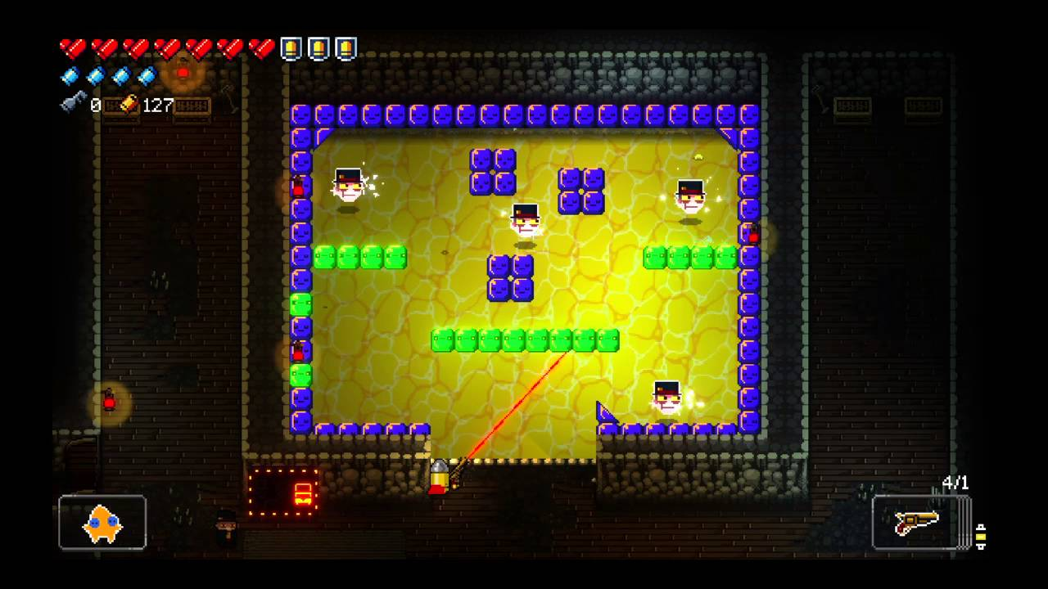

**OUR GAME**

As our game will be multiplayer and therefore larger-scale, we will likely require a wider range of blocks and targets, as well as resulting effects in order to keep the game interesting and encourage competitive play. As such, some of these effects should be designed to either benefit the current player or serve to hinder the opponent to provide the incentive for the player to want to obtain them. Ideas for other potential blocks are below:

(Blocks that can benefit the current player on their next turn)

* **Extra Time** (Adds X amount of seconds to the player’s timer)
* **Extra Reflection** (Adds X more times a projectile can reflect off of blocks)
* **Reduce Movement Speed of Targets**
* **Extra Point(s)** (If the player destroys a target on their next turn, they are awarded extra points)

(Blocks that can hinder the opposing player on their next turn)

* **Reduced Time** (Reduces the opponent’s timer by X amount of seconds)
* **Reduced Reflections** (Reduces the number of times a projectile can reflect off blocks by X)
* **Reduced Accuracy** (The trace line moves slightly out of line of the turret’s aim – this is the direction in which the projectile will actually fire)
* **Increase Movement Speed of Targets**

(Other blocks)

* **Gate/Switch Blocks** (Required for the player to hit in order to open a nearby gate in the level. These gates could close again randomly and require them to be reopened)
* **Bomb Blocks** (Can destroy blocks in a small radius around it – blocks that make up the edge of the level cannot be destroyed)
* **Portal Blocks** (When a projectile enters one, it is fired out from another in a different location in the level)

(Different target types)

* **False Targets** (When destroyed, reveals the real target in a different location)
* **Shielded Targets** (Requires multiple hits to be destroyed – the player who destroys the target scores the point)
* **Large Targets** (Larger than other targets, but only one side is vunerable – all other sides destroy the projectile. This side can changes each turn. This could be used as an optional tie-breaker if the players draw at the end of the game)
* **Teleporting Targets** (Teleports to a different location in the level at the end of every turn)

(Some of these mechanics could also be combined into a single target to make them more difficult)